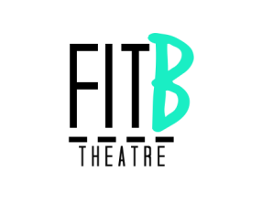
Director’s Notes
Week Commencing: 13/04/15

Rehearsal plan
Rachel’s physical warm-up
Carry on working on the ribbon sequence
Ask cast to think of ways we can include ‘the pill’ / questioning whether we can delete our memories.
Hannah and Alice to work on The Wife’s speech before she leaves her husband

Post rehearsal thoughts
Most of this rehearsal consisted of the cast being left to play around with the ribbons, to see what interesting shapes and movements they could create when using the ribbon and being connected.
The cast also had ideas about projecting The Wife researching about amnesia online / trying to understand the illness more and seeing if there are ways to help her husband. It is then she comes across information about manually deleting memories.
There was also an idea about The Wife having a speech where she expresses how much she has tried to stick by her husband but doesn’t know if she can do it anymore – she is finding it too much to handle remembering everything the way it used to be.
Hannah and Alice wrote a paragraph for the chosen Wife to speak before leaving her husband – I just need to edit it and fit it into the script.

